Short-term plan
Unit 7 | Holidays
Teacher’s name | Kalysheva Lyazzat Perdebayevna
School | M Gorky
Date | 15.04.2025year
Grade | 5 “а”
Theme | An email about a holiday
Learning objectives | 5.4.3.1 understand the detail of an argument on a limited range of familiar general and curricular topics  5.5.7.1 use with some support appropriate layout at text level for a limited range of written genres on familiar general topics and some curricular topics
Lesson objectives | - Identify the main idea in a short email  -Write a basic short text with support  - Summarize key details and write a structured email
Values | Respect the different cultures
Planned activities
Planned timings | Teacher’s activities | Students’ activities | Assessment | Resources
Beginning of the lesson  1 min  Method “Creative Twist”  4 mins  “Travel Ticket” Method  2 mins | - Organization moment  - Checking up the homework  Brainstorming  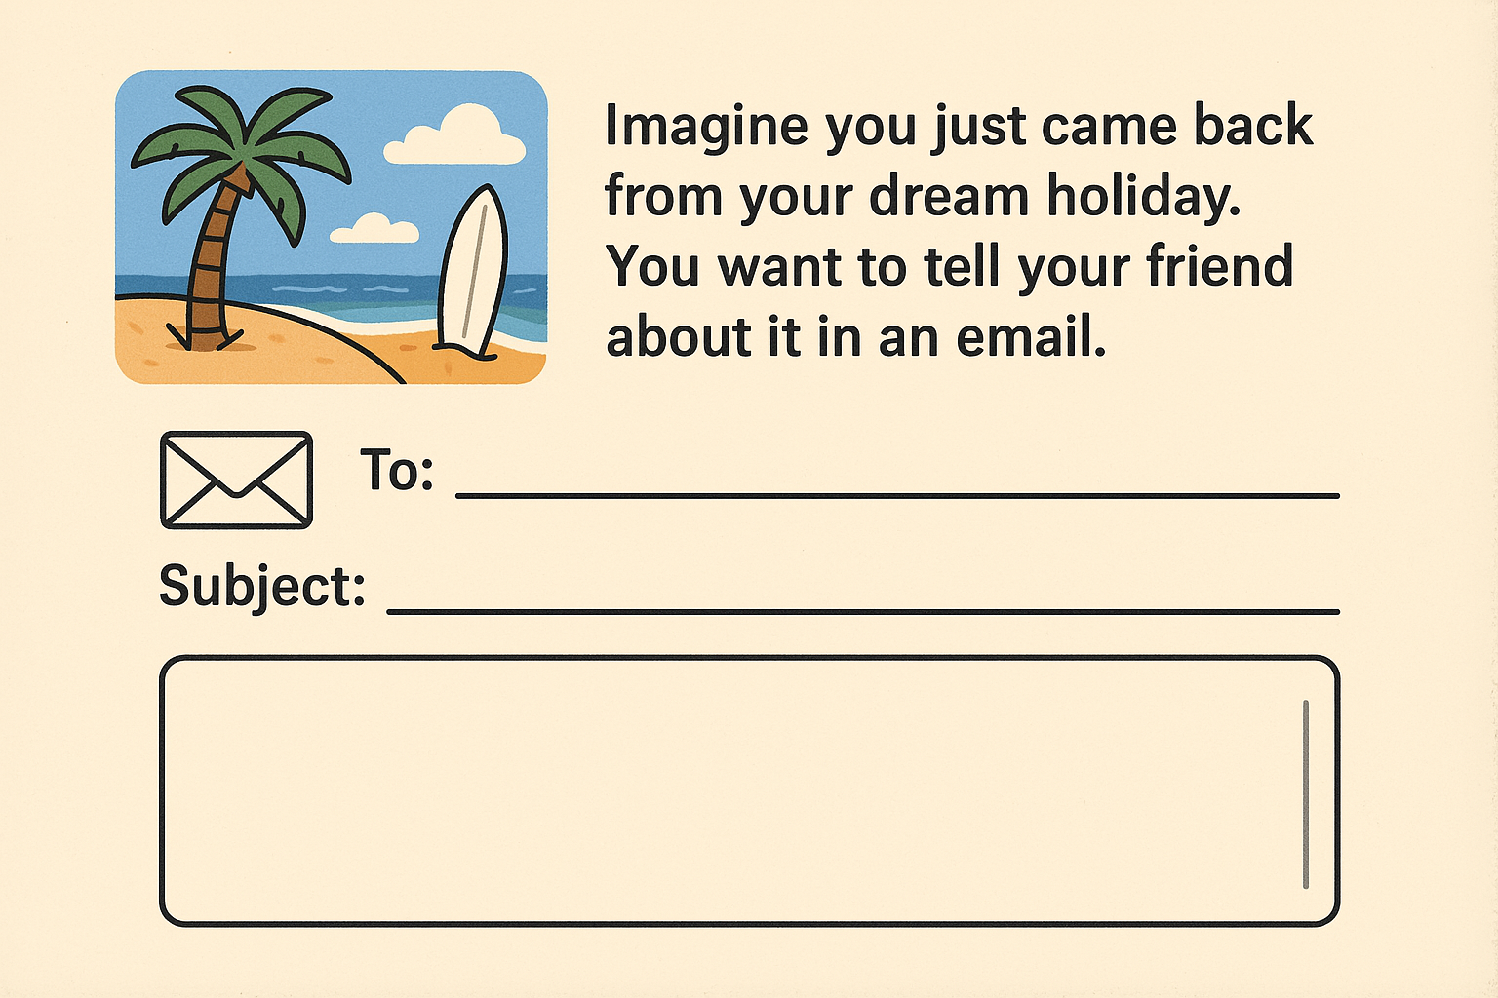  • Where did you go?( e.g., I went to…..)  • Who did you go with? (e.g., I went with……)  • What did you do there? (e.g., I visited……..)  • How was the weather/food/people? (e.g., The weather was……..)  Divide into groups  ✈️ Three routes (three groups):  “Beach Airlines” – beach vacation  “Mountain Express” – mountain travel  “City Tour Airways” – city tours  🧍 🧍‍♀️ Grouping method:  Students choose a ticket.  Each finds students in their direction and gathers in a group. | Greets the teachers  The student will learn about the questions required for writing a letter by answering the following questions:  Each student gets a ticket, finds a classmate who is going in the same direction, and sits in that group. | Verbal Assessment  Verbal Assessment  Verbal Assessment | Interactive panel  Handouts  Flashcards:  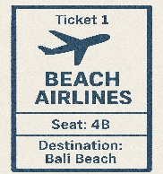  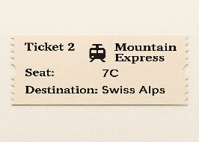  
Middle of the lesson  Presentation  of the new theme:  7 mins  Group work Method: "Understand – Group – Share"  To develop functional literacy, a letter related to life  10 mins  🎲 “Holiday Dice” game  8 mins  Method: "RAFT Strategy" (R – Role: student, A – Audience: friend, F – Format: letter, T – Topic: vacation)  My author's program is designed to develop students' writing skills through The program focuses on developing writing fluency, structure, and self-expression through engaging activities such as journaling, letter writing, comics, and dialogues.  8 mins | The new theme: "An Email About a Holiday" ✉️🌴  🧱 Stage 1:  Introduction to Email Structure  Introduce students to the main sections of an email:  ✏️ Example:  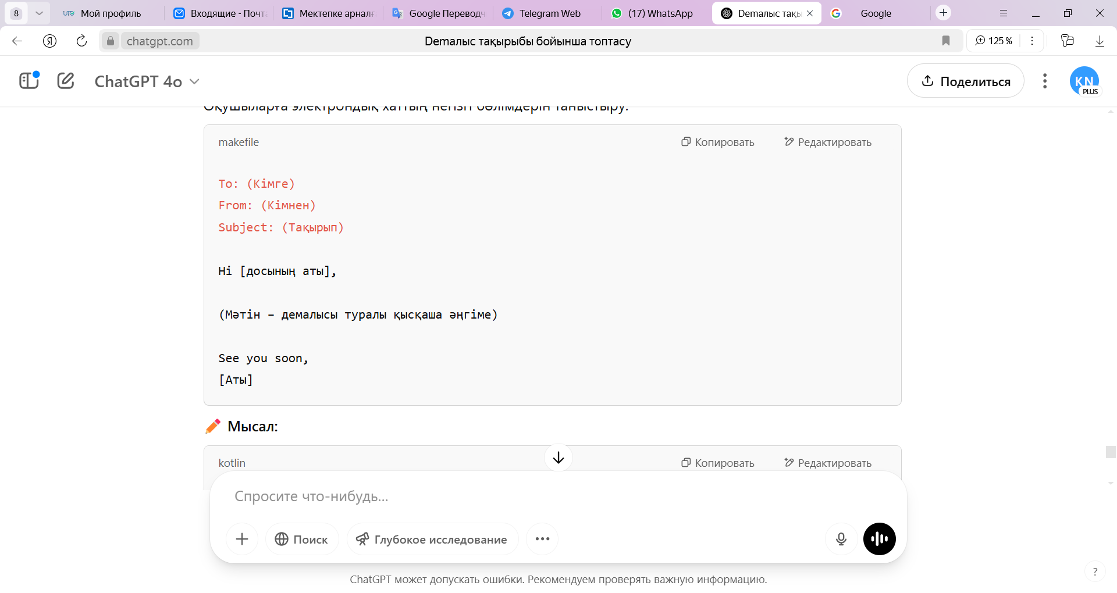  ✏️ Example:  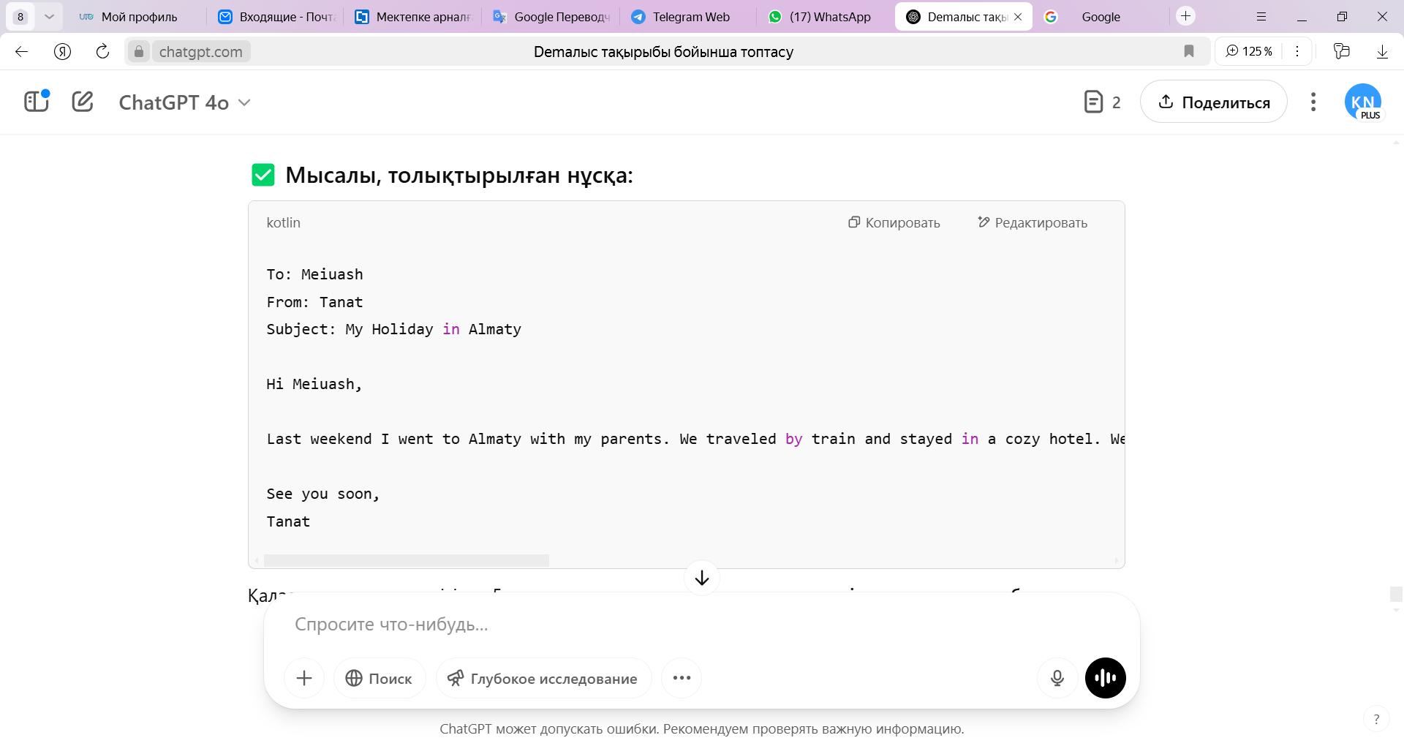  Task I. Group work. Method: "Understand – Group – Share" Reads and gets acquainted with the letter.  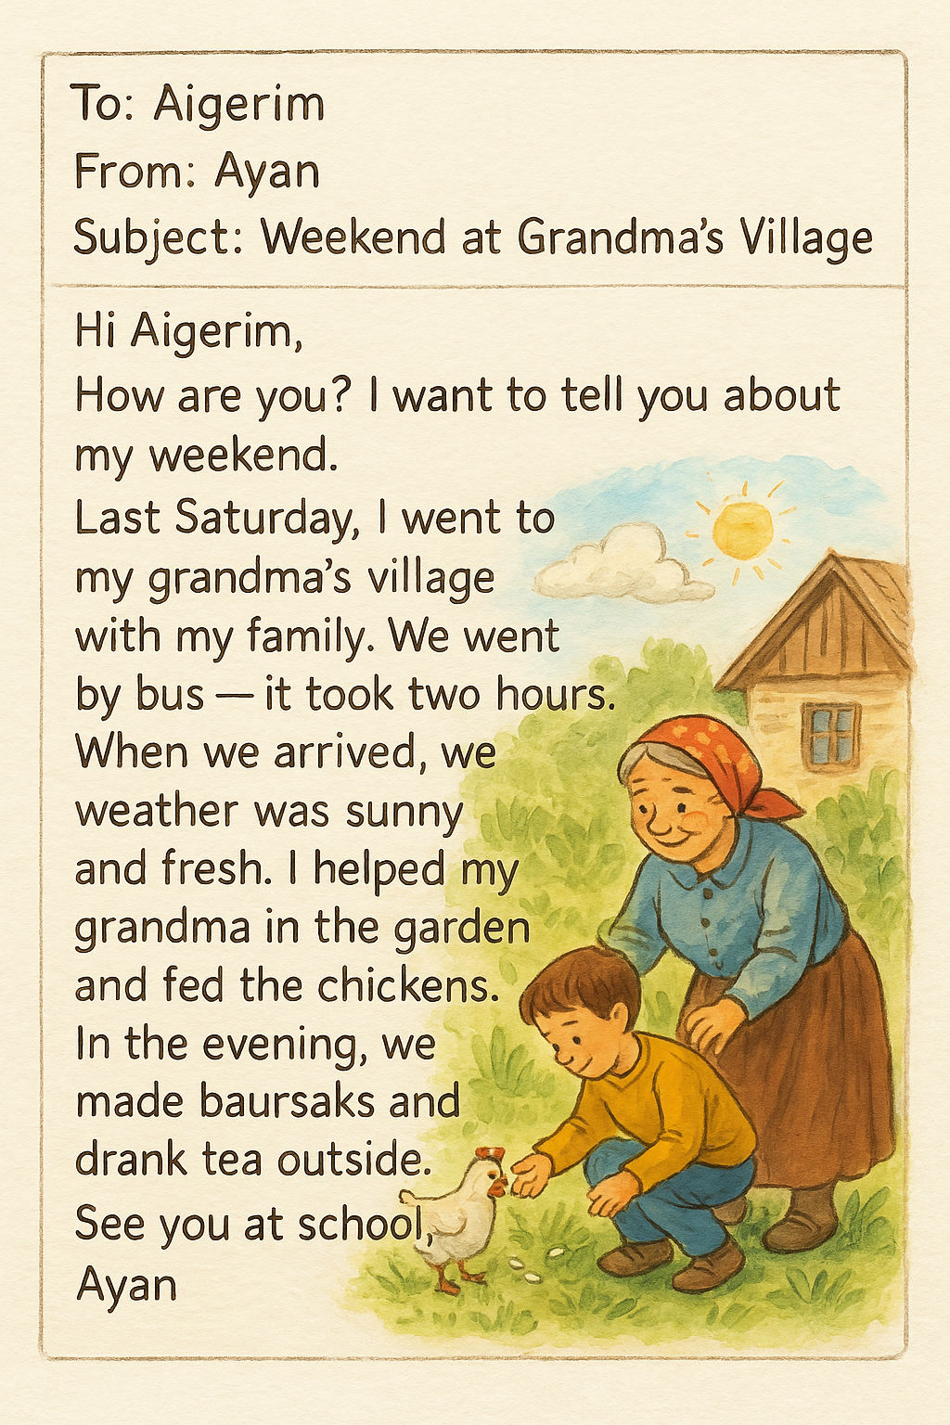  This task is very effective for the All learners category. Picture or word support is provided if necessary.  📷 Village, Garden, Chicken, Bus  📖 went, helped, ate, took photos  ✏️Task 1. 📩 Read the email and answer the questions:  ✅ Where did Ayan go?  → ___________________________________  ✅ Who did he go with?  → ___________________________________  ✅ What did he do?  → ___________________________________  ✍️Complete the following sentences:  Last Saturday, I went to _________.  The weather was __________.  We __________ and __________.  Task II. Pair work. 🎲 “Holiday Dice” game:  Students roll the dice and make a sentence for each section:  🧩 Game progress:  Each group is given a dice (d6 – 6-sided).  Students in the group take turns rolling the dice and forming sentences according to the table below.  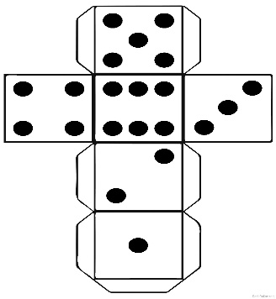1. Where did he go?  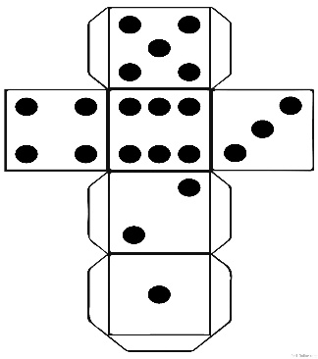2. Who did he go with?  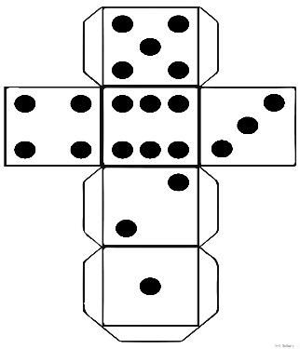 3. What did he do?  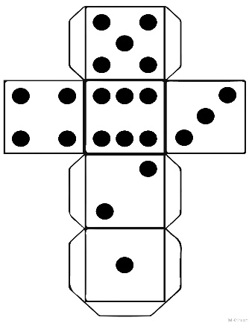1. Where did he go?  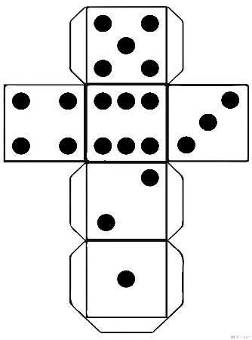4. What was the weather like?  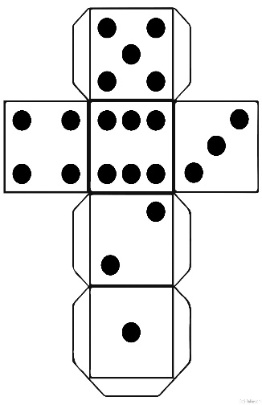2. Who did he go with?  ✍️ Task III: Individual work — Writing a letter  Task:  Based on your own experience, write an email:  ➤ Keep the correct structure (To, From, Subject)  ➤ Write with paragraphs, emotion, and specific actions  ➤ Add a closing sentence ("See you soon")  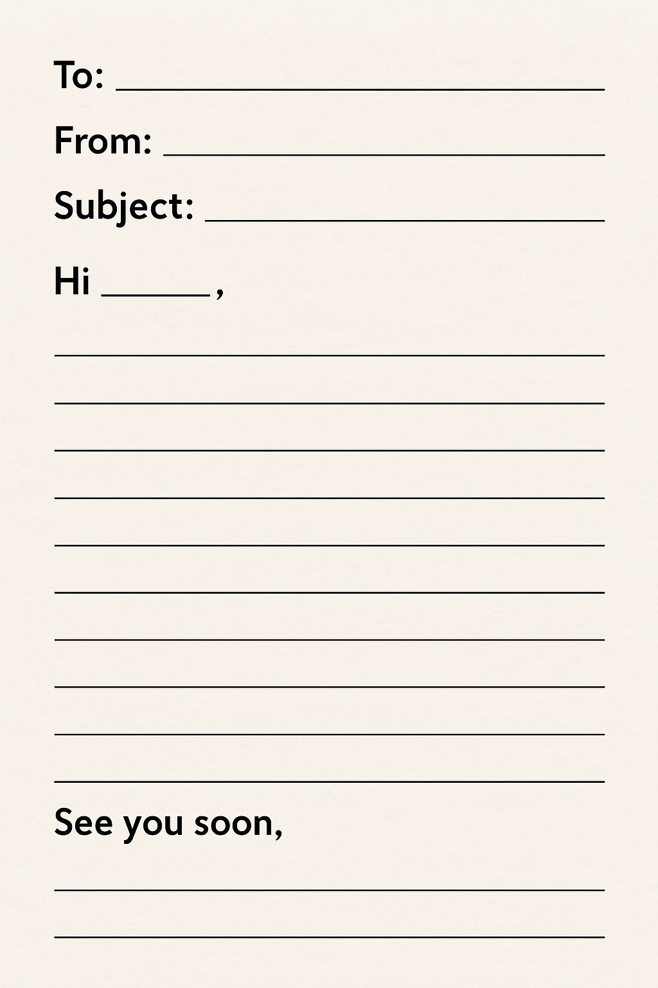 | -Listens to the teacher attentively  -After understanding the theme, they follow the examples.  Understand the main information about the letter.  Read the text and answer the main questions, then complete the task  Students roll the dice and make sentences for each section:  ✅ Peers listen to each other’s sentences and award points based on accuracy and clarity.  Based on their own experience, write an email  ✅ Students use this checklist to assess their writing. | - understanding the structure of an email  -writing a letter about your vacation  -expressing your thoughts in simple sentences  .  Group Assessment  Read the text and determine where Ayan went and and identify who Ayan went with from the letter-1 point  Correctly complete the blank sentences (3 sentences)-1 point  2 points  Couples evaluate each other through the "Postcard swap" method  Peer Assessment  Descriptor:  - Forms a correct sentence about – 2 points  Uses correct grammar and sentence structure – 1 point  3 points  Self-Assessment  Descriptor:  -Uses letter structure correctly–2 points  - Composes 3–4 correct sentences -2 points  Names places of rest, actions and feelings - 1 point  Total: 5 points  Total: 10 points | Interactive panel  Handouts  Interactive panel  Handouts  Worksheets  Flashcards:  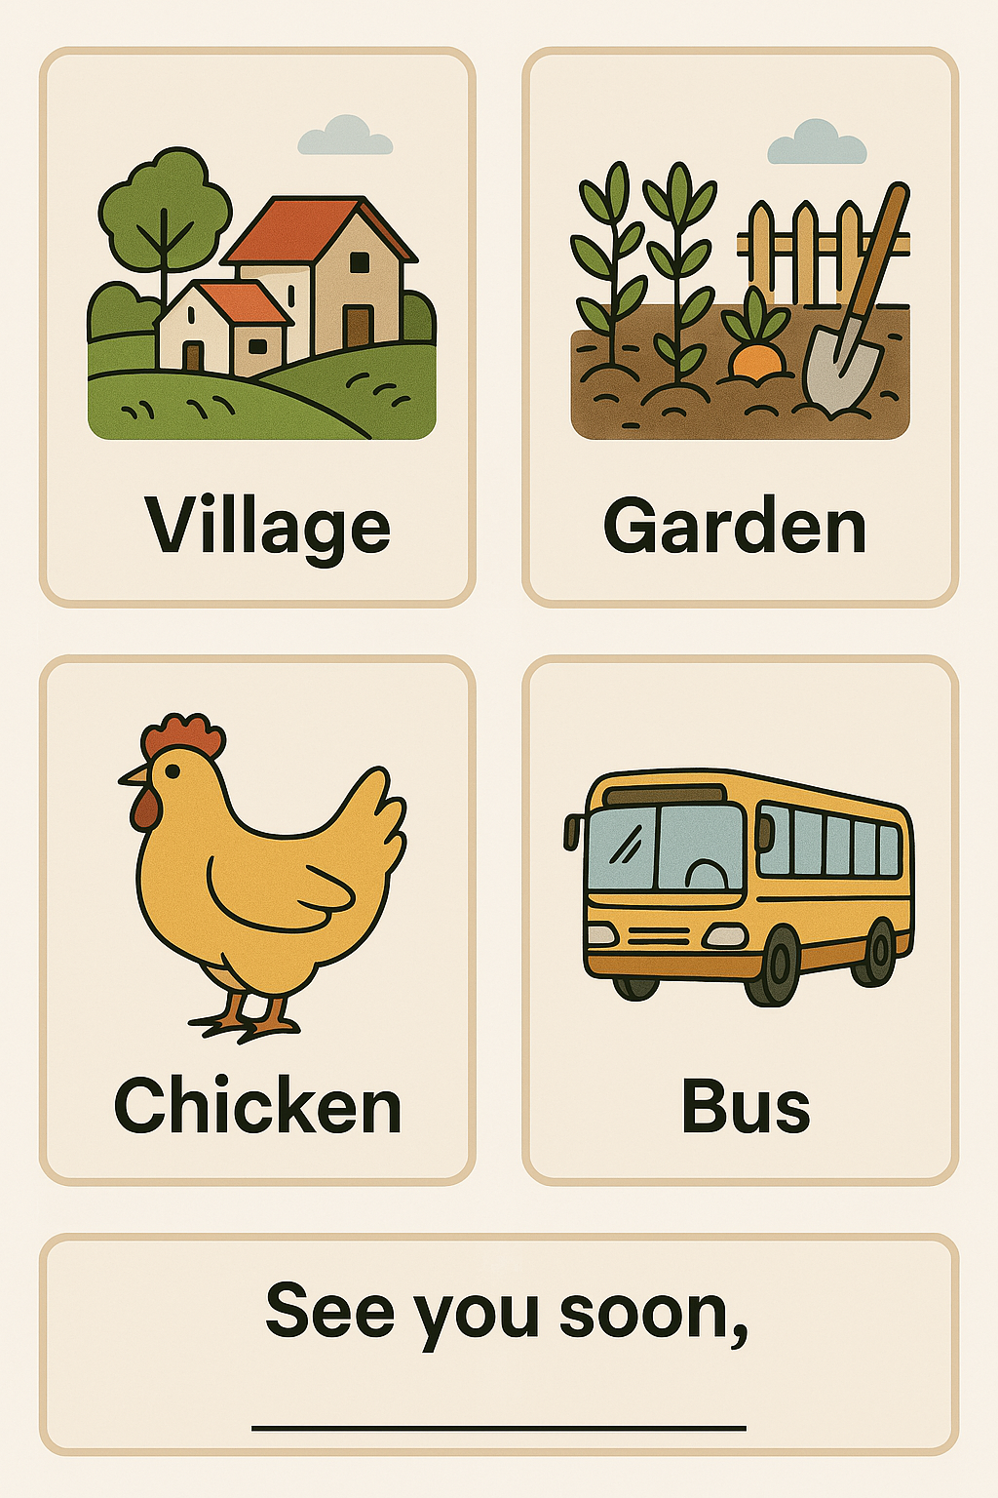  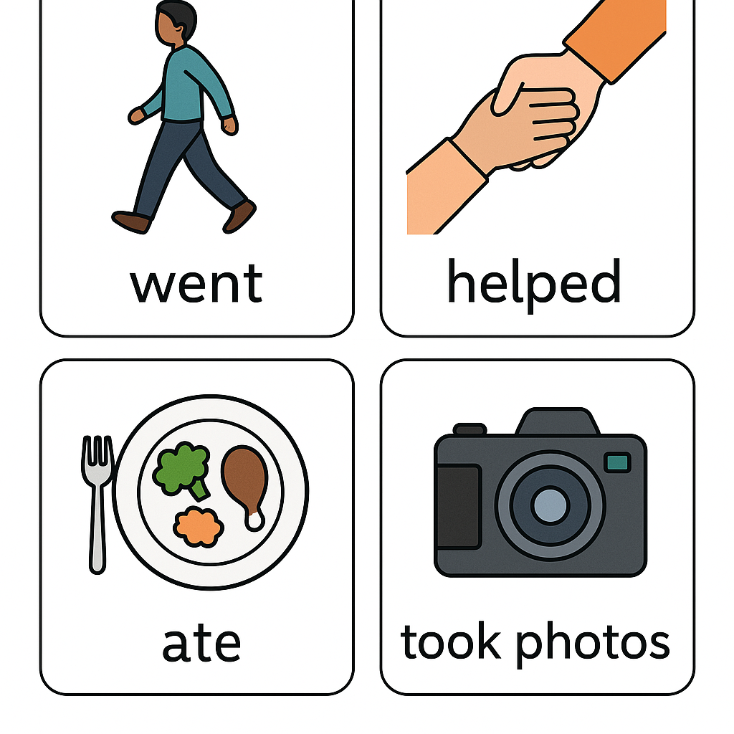  Interactive panel  Worksheets  Handouts  Dice (for the Holiday Dice activity)  Writing template/email frame
End of the lesson  Reflection  2 mins  Feedback  1 min  Assessment  1 min  Homework  1 min | Complete the sentences based on what they learned today:  👩‍🎓 My Reflection  - What did you do well? ✏️  I am proud because I... (Мен мынаған қуандым, себебі мен...)  - What was difficult for you? ✏️  It was hard for me to... (Маған қиын болғаны...)  - What will you try to do better next time? ✏️  Next time I want to... (Келесі жолы мен... жақсартқым келеді.)  Getting feedback from students using the “Cup method”  Assess students based on the assessment sheet  Hometask: Write a letter about your last holiday “Nauryz” | Completes the sentences according to their knowledge that they got from this lesson  Provides feedback through the “Cup method”  Students are assessed based on the assessment sheet. | -choose the correct form of adjectives  -Provides the right word.  -Reflects on their learning and progress. | Interactive panel  Worksheets  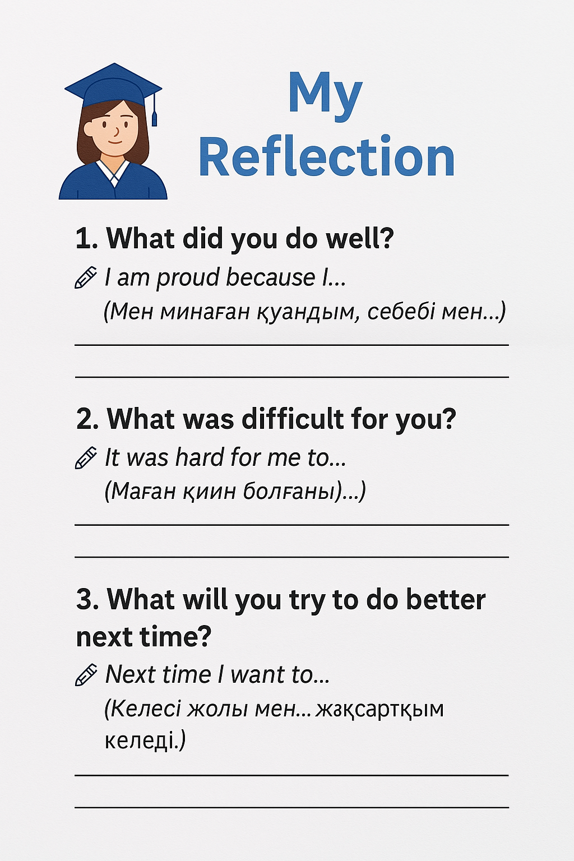

✅ Descriptor: Task 1
Топтың аты:
№ | Evaluation criteria | Yes-1 point | No-0
1 | Read the text and determine where Ayan went and and identify who Ayan went with from the letter | ✅ | ❌
2 | Correctly complete the blank sentences (3 sentences) | ✅ | ❌

🤝 Peer Assessment Postcard Swap Descriptor Task 2.
№ | Descriptor | Points | Partner’s name
1 | Forms a correct sentence about the topic (place, action, or weather) | 2 pts
2 | Uses correct grammar and sentence structure | 1 pt
✅ | Total | /3

✉️ Self-Assessment: Descriptor Task 3.
№ | Descriptor | Points | Name
1 | Uses letter structure correctly (To, From, Subject, Hi…, See you soon) | 2 pts
2 | Composes 3–4 grammatically correct sentences | 2 pts
3 | Names places of rest, actions, and feelings | 1 pt

